Hi, so far we’ve covered a lot about positioning and a lot of other stuff using a simple white square and a gradient. Today we’re going to learn how to customize objects, then we are going to learn how to use animations!

The uiz manual is a usefull tool, because we can’t cover every little detail in the tutorials, you’ll need documentation for specific attributes of uiz object. The uiz documentation is called “uiZ.chm” and it should have come with uiz. Try to find it inside included files.

Open up the objects folder, and click any, you can see there all settable variables in this syntax:

-variable_name[default_value]: Description.

IMAGE 18

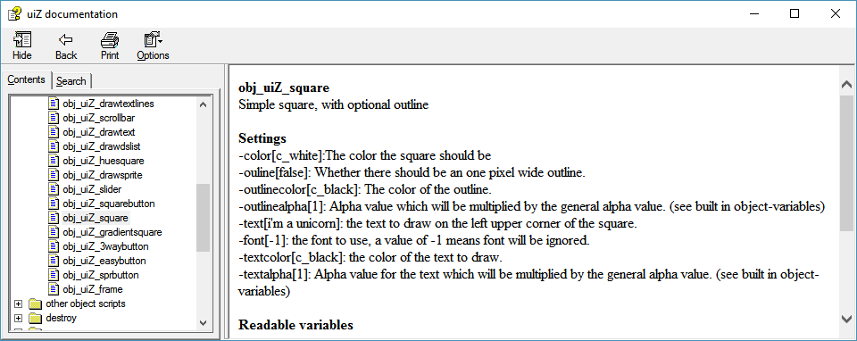

Now open the obj_uiZ_rotator page, and you can see that it has two special variables called “rotationtime” and “animation”. Rotationtime is a time in seconds, just like most time/speed values in uiz.

*Technical details:* **Why seconds?** Well, your game might run on a room_speed of 30 (30 ticks per second), or on a room speed of 60. Using values in ticks instead of seconds would mean that the animation would take different times on different room speeds. 30 ticks would take one second if the room_speed was 30. But if the room_speed was 60, then it would take only half of that time. So uiz automatically calculates how many ticks fit in all those seconds, and then uses those values. It even supports mid-animation room_speed changes which will not give you any problems.

For what animations to use, you can see the manual for “Animations in general” inside the animations tab.

There are a few general guidelines concerning which animations to use, and which not to use in certain situations:

IMAGE 19:

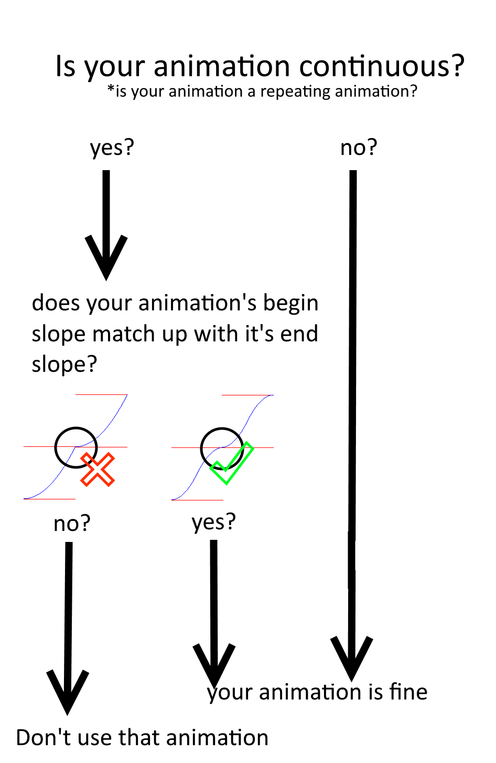

That was it for this time, try the animations out, by placing a few obj_uiZ_rotator objects.